**BANK LOAN REPORT QUERY DOCUMENT**

1. **BANK LOAN REPORT | SUMMARY**

KPI’s:  
**1.** **Total Loan Applications:**  
  
SELECT COUNT(id) AS [Total Loan Applications] FROM dbo.financial_loan;  
  
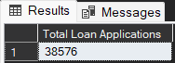

**2.** **MTD Loan Application:**

SELECT COUNT(id) AS [Total Application] FROM financial_loan

WHERE MONTH(issue_date) = 12 AND YEAR(issue_date) = 2021;  
  
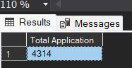  
  
  
**3. Previous MTD Loan Application:**

SELECT COUNT(id) AS [PMTD_Total Application] FROM financial_loan

WHERE MONTH(issue_date) = 11 AND YEAR(issue_date) = 2021;  
  
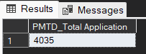  
  
**4. Total Funded Amount:**

**SELECT SUM(loan_amount) as [Total Funded Amount] from financial_loan  
  
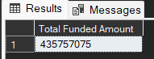  
  
5. Total MTD Funded Loan Amount:**

SELECT SUM(loan_amount) as [MTD Total Funded Amount] from financial_loan

where MONTH(issue_date) = 12 AND YEAR(issue_date) = 2021;

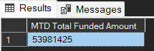  
  
**6. Total Previous MTD Funded Loan Amount:**

SELECT SUM(loan_amount) as [PMTD Total Funded Amount] from financial_loan

where MONTH(issue_date) = 11 AND YEAR(issue_date) = 2021;  
  
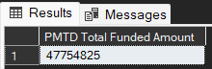  
  
**7. Total Amount Received:**

SELECT SUM(total_payment) AS [Total Amount Recived] FROM financial_loan;  
  
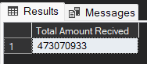

**8. Total MTD Amount Received:**

SELECT SUM(total_payment) AS [MTD Total Amount Recived] FROM financial_loan

WHERE MONTH(issue_date) = 12 AND YEAR(issue_date) =2021;

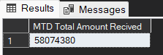   
  
**9.Total PMTD Amount Received:**

SELECT SUM(total_payment) AS [PMTD Total Amount Recived] FROM financial_loan

WHERE MONTH(issue_date) = 11 AND YEAR(issue_date) =2021;  
  
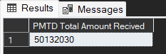

**10. Average interest Rate:**

SELECT AVG(int_rate) AS [Average Interest Rate] FROM financial_loan;  
  
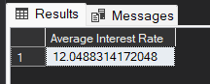  
  
**11. MTD Average interest Rate:**

SELECT AVG(int_rate)*100 AS [MTD Average Interest Rate] FROM financial_loan

WHERE MONTH(issue_date) = 12 AND YEAR(issue_date) = 2021;

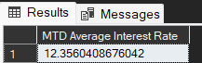

**12. PMTD Average interest Rate:**

SELECT AVG(int_rate)*100 AS [PMTD Average Interest Rate] FROM financial_loan

WHERE MONTH(issue_date) = 11 AND YEAR(issue_date) = 2021;  
  
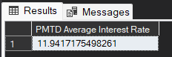  
  
**13. Avg DTI**

SELECT AVG(dti)*100 AS [Average DTI] FROM financial_loan;

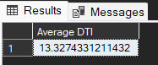

**14. MTD Avg DTI**

SELECT AVG(dti)*100 AS [MTD Average DTI]FROM financial_loan

WHERE MONTH(issue_date) = 12 AND YEAR(issue_date) = 2021;  
  
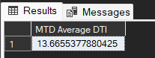

**15. PMTD Avg DTI**

SELECT AVG(dti)*100 AS [PMTD Average DTI]FROM financial_loan

WHERE MONTH(issue_date) = 11 AND YEAR(issue_date) = 2021;  
  
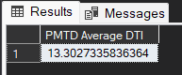  
  
  
GOOD LOAN ISSUED:

**1. Good Loan Percentage:**

SELECT

(COUNT(CASE WHEN loan_status = 'Fully Paid' or loan_status = 'Current'

THEN id END )*100)/

COUNT(id) AS [Good Loan Percentage]

from financial_loan;

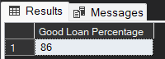  
  
  
**2. Good Loan Application**

SELECT COUNT(id) AS [Good Loan Application] from financial_loan

WHERE loan_status = 'Fully Paid' or loan_status = 'Current';  
  
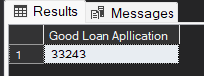  
  
**3. Good Loan Funded Amount:**

SELECT SUM(loan_amount) AS [Good Loan Funded Amount] from financial_loan

WHERE loan_status = 'Fully Paid' or loan_status = 'Current';  
  
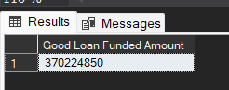

**4. Good Loan Amount Received:**

SELECT SUM(total_payment) AS [Good Loan Funded Amount]from financial_loan

WHERE loan_status = 'Fully Paid' or loan_status = 'Current';  
  
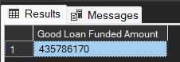

GOOD LOAN ISSUED:  
  
**1.Bad Loan Percentage:**

SELECT

(COUNT(CASE WHEN loan_status = 'Charged off'

THEN id END )*100)/

COUNT(id) AS [Bad Loan Percentage]

from financial_loan;  
  
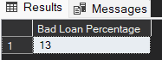  
  
**2. Bad Loan Applications:**

SELECT COUNT(id) AS [Bad Loan Application] from financial_loan

WHERE loan_status = 'Charged Off';  
  
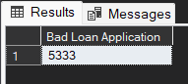  
  
**3. Bad Loan Funded Amount**

SELECT SUM(loan_amount) AS [Bad Loan Funded Amount]from financial_loan

WHERE loan_status = 'Charged Off';

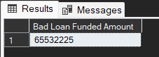

4. **Bad Loan Amount Received**

SELECT SUM(total_payment) AS [Bad Loan Funded Received]from financial_loan

WHERE loan_status = 'Charged Off';  
  
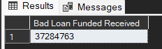

LOAN STATUS:

SELECT loan_status,

COUNT(id) AS Total_Loan_Application,

SUM(total_payment) AS Total_Amount_Received,

Sum(loan_amount) AS Total_Amount_Funded,

AVG(int_rate * 100) AS Interest_Rate,

AVG(dti * 100) AS DTI

FROM financial_loan

GROUP BY loan_status;  
  
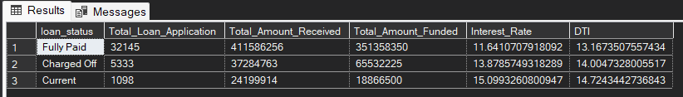  
  
  
MTD Received Amount

SELECT loan_status,

SUM(total_payment) AS MTD_Total_Amount_Received,

SUM(loan_amount) AS MTD_Total_Funded_Amount

FROM financial_loan

WHERE MONTH(issue_date) = 12

GROUP BY loan_status

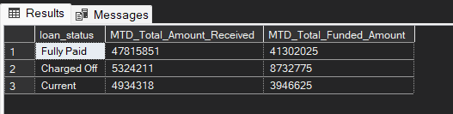 **BANK LOAN REPORT | OVERVIEW**

MONTH

SELECT

MONTH(issue_date) AS Month_Munber,

DATENAME(MONTH, issue_date) AS Month_name,

COUNT(id) AS Total_Loan_Applications,

SUM(loan_amount) AS Total_Funded_Amount,

SUM(total_payment) AS Total_Amount_Received

FROM financial_loan

GROUP BY MONTH(issue_date), DATENAME(MONTH, issue_date)

ORDER BY MONTH(issue_date);  
  
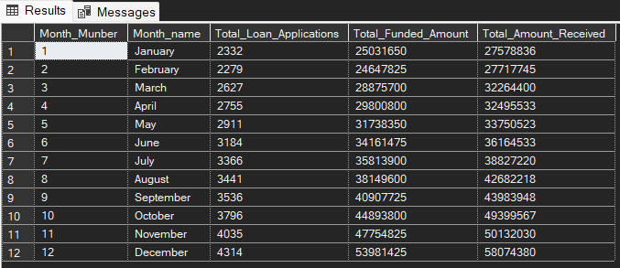

STATE

SELECT

address_state AS State,

COUNT(id) AS Total_Loan_Applications,

SUM(loan_amount) AS Total_Funded_Amount,

SUM(total_payment) AS Total_Amount_Received

FROM financial_loan

GROUP BY address_state

ORDER BY address_state  
  
  
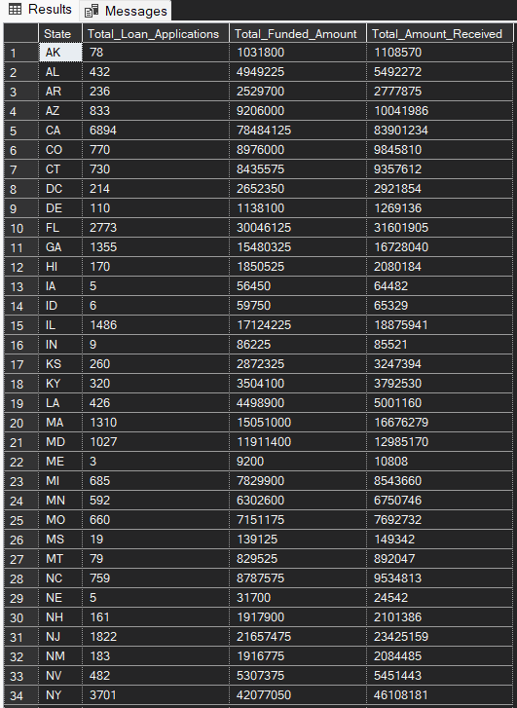  
  
  
--TERM

SELECT

term AS Term,

COUNT(id) AS Total_Loan_Applications,

SUM(loan_amount) AS Total_Funded_Amount,

SUM(total_payment) AS Total_Amount_Received

FROM financial_loan

GROUP BY term

ORDER BY term  
  
  
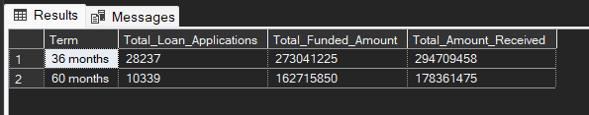  
  
  
  
EMPLOYEE LENGTH

SELECT

emp_length AS Employee_Length,

COUNT(id) AS Total_Loan_Applications,

SUM(loan_amount) AS Total_Funded_Amount,

SUM(total_payment) AS Total_Amount_Received

FROM financial_loan

GROUP BY emp_length

ORDER BY emp_length  
  
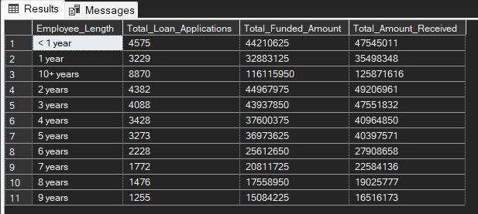  
  
  
PURPOSE

SELECT

purpose AS PURPOSE,

COUNT(id) AS Total_Loan_Applications,

SUM(loan_amount) AS Total_Funded_Amount,

SUM(total_payment) AS Total_Amount_Received

FROM financial_loan

GROUP BY purpose

ORDER BY purpose;  
  
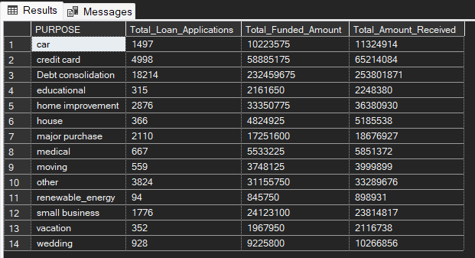

HOME OWNERSHIP

SELECT

home_ownership AS Home_Ownership,

COUNT(id) AS Total_Loan_Applications,

SUM(loan_amount) AS Total_Funded_Amount,

SUM(total_payment) AS Total_Amount_Received

FROM financial_loan

GROUP BY home_ownership

ORDER BY home_ownership;  
  
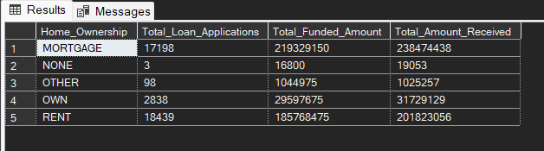  
  
  
Grade A in the filters for dashboards.

SELECT

purpose AS PURPOSE,

COUNT(id) AS Total_Loan_Applications,

SUM(loan_amount) AS Total_Funded_Amount,

SUM(total_payment) AS Total_Amount_Received

FROM financial_loan

WHERE grade = 'A'

GROUP BY purpose

ORDER BY purpose;  
  
